______St. Pius X 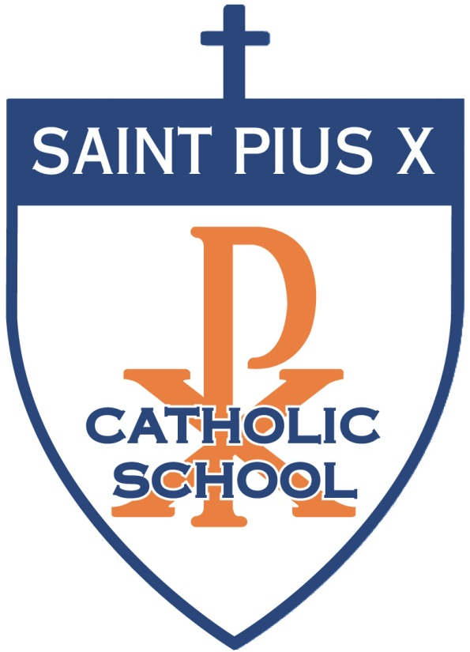Catholic School_____
G-3139 Hogarth Avenue Flint, Michigan 48532 Tel: 810-235-8572 Fax: 810-235-2675
Website: www.spxparish.com E-mail: rjkaplan@gmail.com
Date: September 29, 2017
Dear Parents and Guardians,

Pursuant to Article 12 of the United States Conference of Catholic Bishops Charter for the Protection of Children and Young People, we are offering safe environment education and training for children and youth enrolled in our school education program.
We will be using the Praesidium Called to Protect for Youth program for students in grades 6 through 8 and Safe Sheep in Our Flock program for students in grades K-5 during October 2017. Both programs have been carefully developed and you as a parent can view training resources at www.praesidiuminc.com and www.safesheep.com.
The scheduled class lessons are being offered at St. Pius X Catholic School during the month of November 2016. As a parent or guardian you have the right to choose whether your child participates. Please read the description of the program at the links above so you will be aware of the nature of the programs.
If you have questions after reviewing the material, please call the principal at 235-8572. If you decide you do not want your child to participate, please complete the opt-out form below and return it to the office by the deadline of Monday, October 2, 2017.
- - - - - - - - - - - - - - - - - - - - - - - - - - - - - - - - - - - - - - - - - - - - - - - - - - - -
Opt-out form for use with the Safe Sheep in Our Flock & Called to Protect for Youth program:
St. Pius X Catholic School does not have my permission to present the Safe Sheep and/or Called to Protect for
Youth program, to my child whose name is ____________________________________________.
Parent/Guardian Name (please print) _____________________________________________________
Parent/Guardian Signature ______________________________________________________________
Date _________________________________

ONLY SIGN IF YOU DO NOT WANT YOUR CHILD TO PARTICIPATE.
The mission of St. Pius X Catholic School is to provide superior academics in a joyful, safe, welcoming, Catholic, family environment.

